↑Upload your Photo | · English Name 여권 영어이름 (※ Same as in your passport) |  | · Gender 성별
 |  |  | (Click)
 | · Date of Birth (YYMMDD) | · E-mail 이메일 | · Nationality 국적
 | · Passport Number 여권번호 | · Passport Expiration Date (YYMMDD) | · Phone Number 전화번호

Home University
· Country 국가 |  | · University Name 대학교 이름 |  |  | · Degree Course 학위과정
 |  |  |  |  | (Click)
· Average GPA (Perfect score / My grades) 학교 성적 |  |  | · Faculty & Major at Home University 전공 ※ Ex: Business / Tourism
( ) / ( ) ※ Ex : 4.0 / 3.59
· Number of completed semesters: Completed a total of (Click) until now including current semester
International Affairs of Home University 国际交流组
· Staff Name 담당 직원 |  |  |  | · Position 직책
(Click)
· E-mail |  |  |  | · Office Phone Number 전화번호 |  | · Zip code 우편번호
· Post Address of International Office 국제교류부서 우편주소

Host University ( KNU )
· Desired Department at KNU 희망 소속학과 (▮ College ▮ Department or Major)

co
[ 1st Choice ] | (Click)
[ 2nd Choice ] | (Click)
※ It must be the same or similar to your major. ※ No guarantee that you are accepted by your desired department.
· Desired Study Period 수학기간 |  | · Language proficiency 한국어 & 영어 능력
(Click) |  | [ Korean ] : | (Click) | [ English ] : | (Click)
※ [Dormitory: Mandatory] The Office of International Affairs processes the dormitory application on behalf of you only
in the first semester. So you don’t need to care about an accommodation application.

I hereby verify that the information on this application is true and pledge to perform the campus life diligently as an exchange student to KNU. If the details on the application are not true, I will accept any measures by the KNU without objection.
Applicant Name January 1, 2018

자기소개 & 수학계획서
Self-introduction & Study Plan
Home University and Country
Name
Major

* in Korean or English / 1 page is enough

Please erase the box below when you submit this application form. 신청서를 제출할 때에는 아래 박스를 지워주세요.
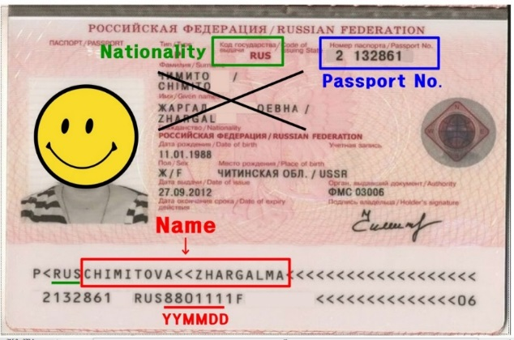 | Spelling MUST be exactly the same written in your passport.  ○ Please be sure to use the same name as the one written at the bottom part of a passport in the red box. Please pay attention to the symbol for the spacing of words ( << ), also, be careful not to include the three-letter country code (e.g. RUS) written before your name.  ○ 交换生填写申请书的时候，请填写护照下方的英文字母(图片中红色部分)  ○ '이름'은 반드시 여권 아래 부분에 보이는 영문 이름과(붉은색 박스)과 동일해야 합니다. 띄어쓰기 표시(<<)에 따라, 이름 사이에 빈 칸을 두고 적어주세요. 예를 들어, 여권 샘플에서 '국가코드("러시아" 국가코드 RUS)를 제외하고 CHIMITOVA ZHARGALMA로 적으면 됩니다.

